Entertainment api

tvshow-list (tv series)
https://dev.e360tv.com/api/v3/tvshow-list

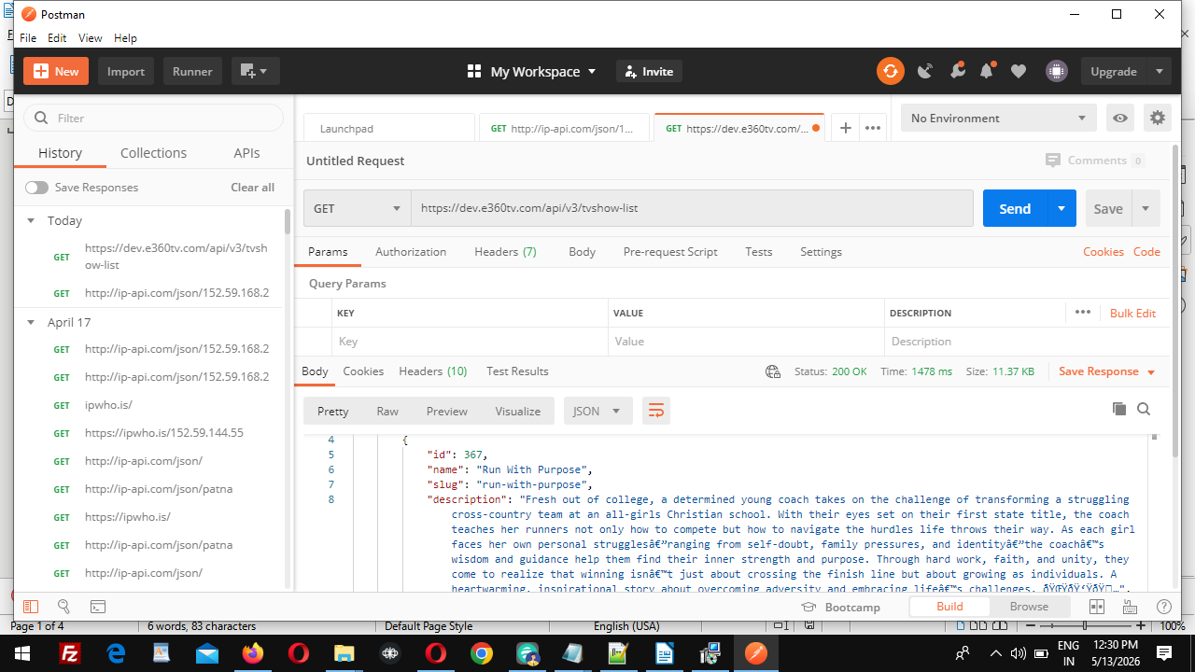

--------------------------------------------------------------------------------------------

movie list api
https://dev.e360tv.com/api/v3/movie-list

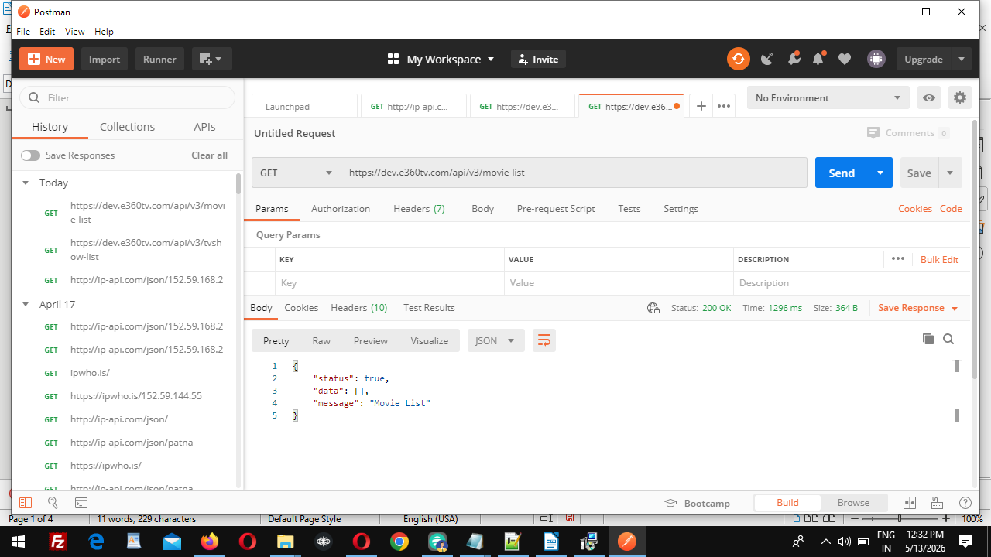
---------------------------------------------------------------------------------------------------

get-search-data api

https://dev.e360tv.com/api/v3/get-search-data?search=sara

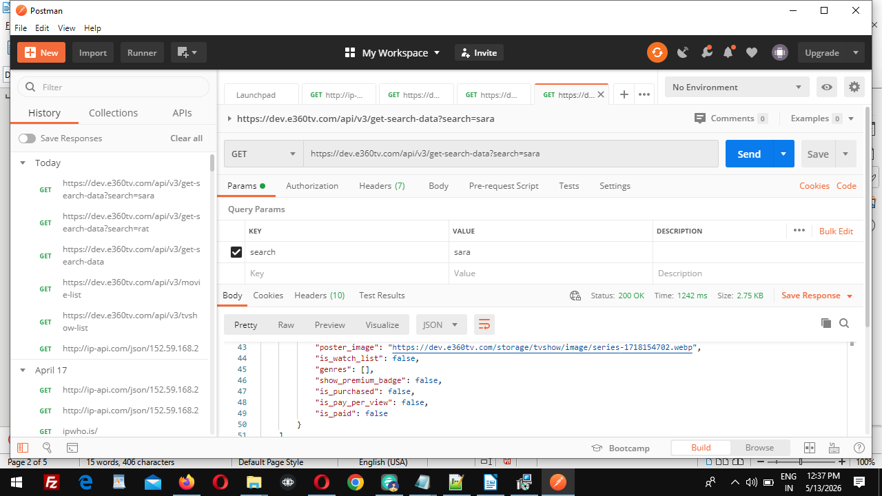
----------------------------------------------------------------------------------------------------

get-rating API

https://dev.e360tv.com/api/get-rating

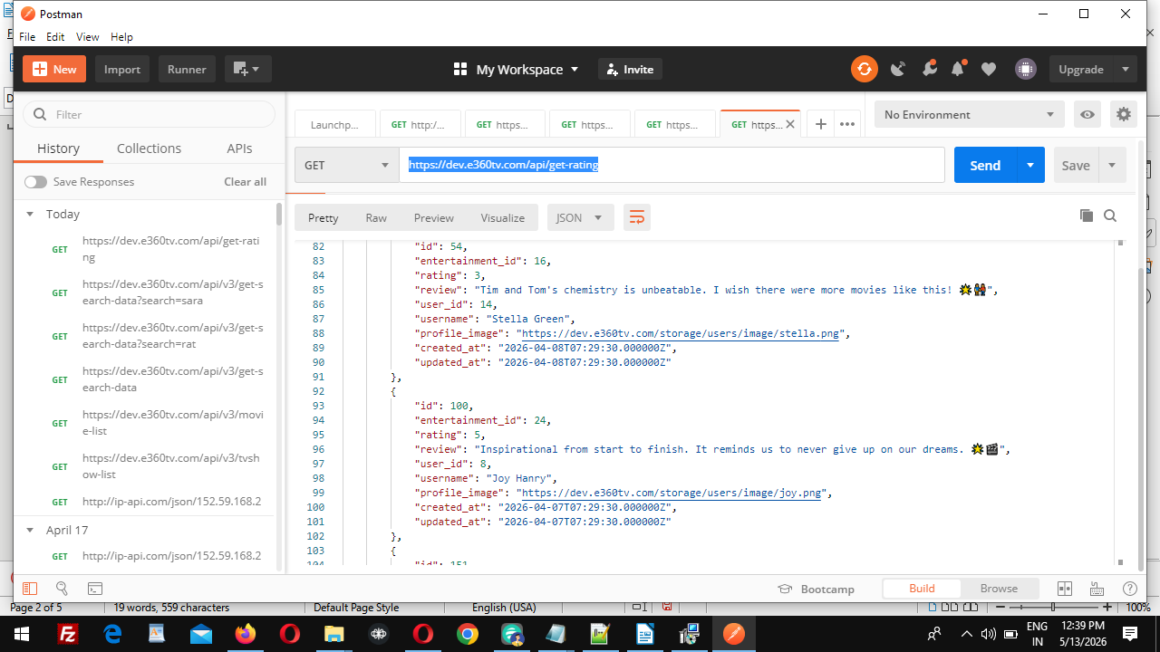
-------------------------------------------------------------------------------------------------------

genre-content-list api

https://dev.e360tv.com/api/genre-content-list

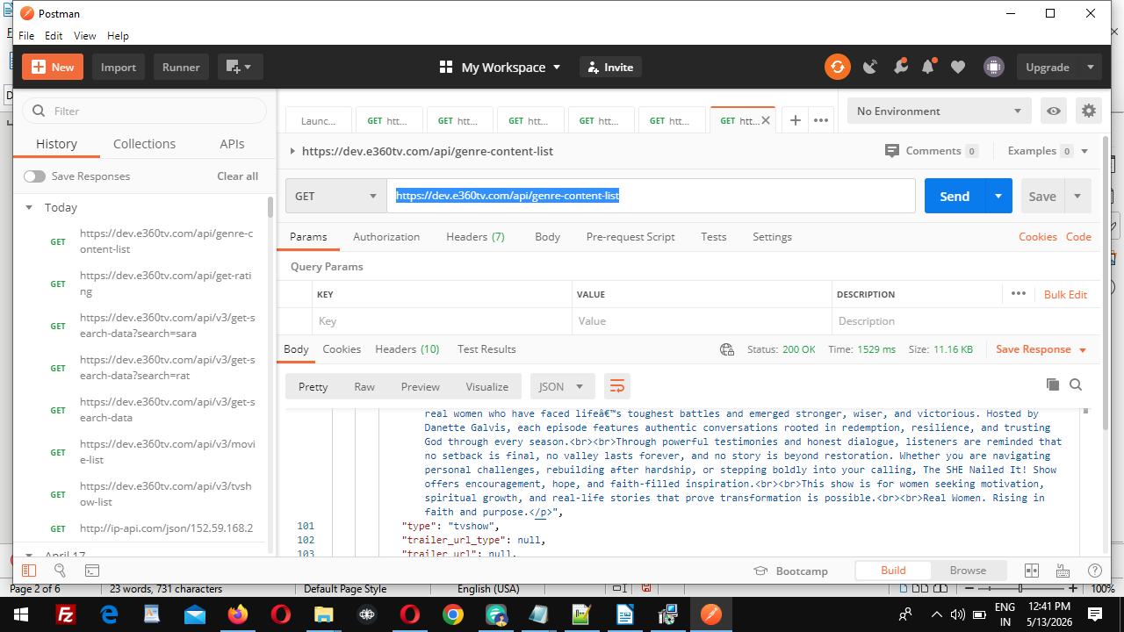

------------------------------------------------------------------------------------------------------

episode-list api
https://dev.e360tv.com/api/episode-list
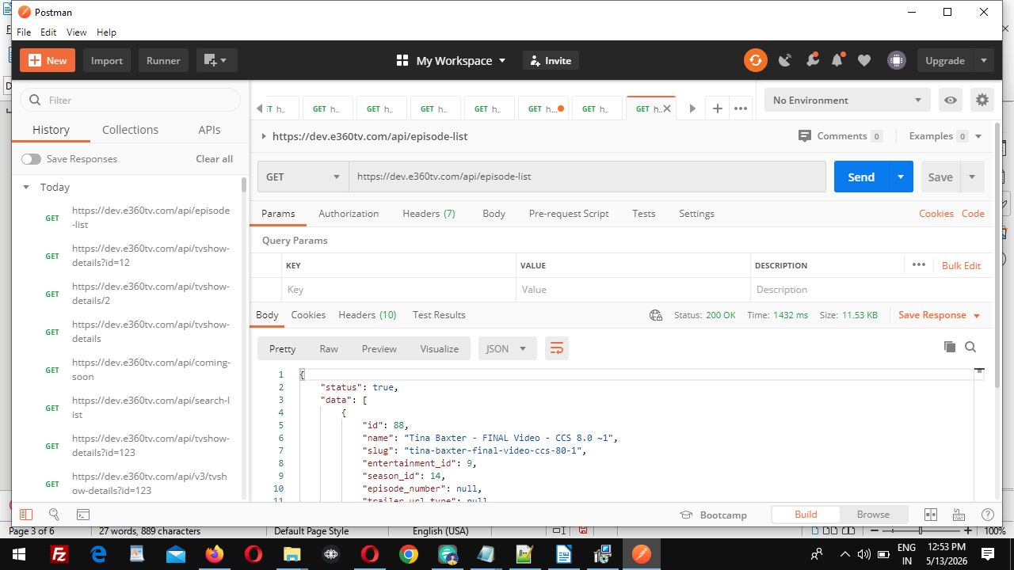
------------------------------------------------------------------------------------------------------------

LIVE TV RELATED API

ivetv-category-list API

https://dev.e360tv.com/api/livetv-category-list

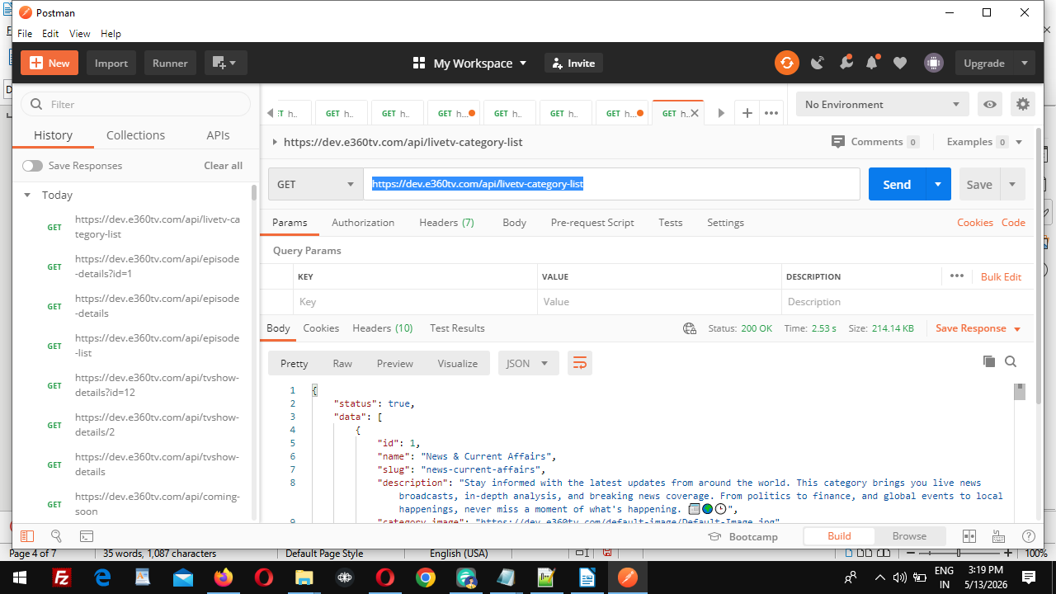

------------------------------------------------------------------------------------------------------------

livetv-dashboard API

https://dev.e360tv.com/api/livetv-dashboard

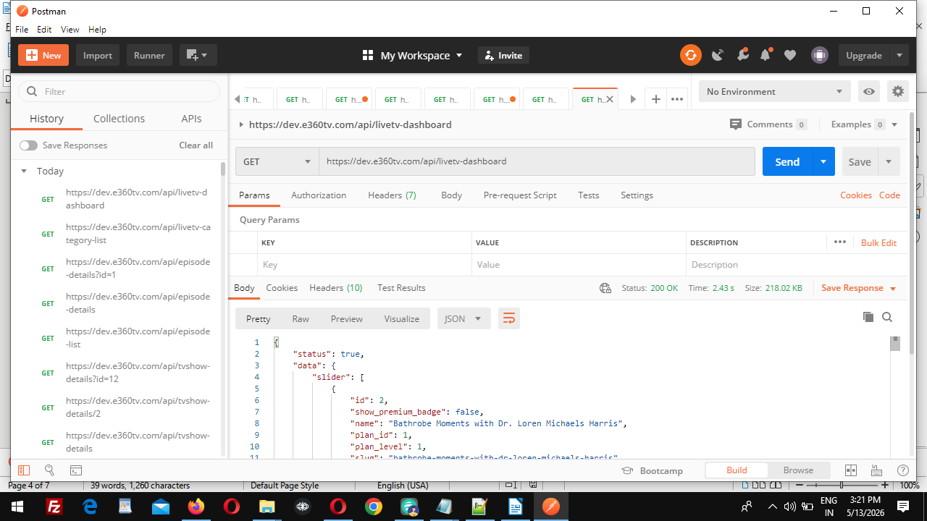
--------------------------------------------------------------------

-----------------------------------------------------------------------------
channel-list API

https://dev.e360tv.com/api/channel-list

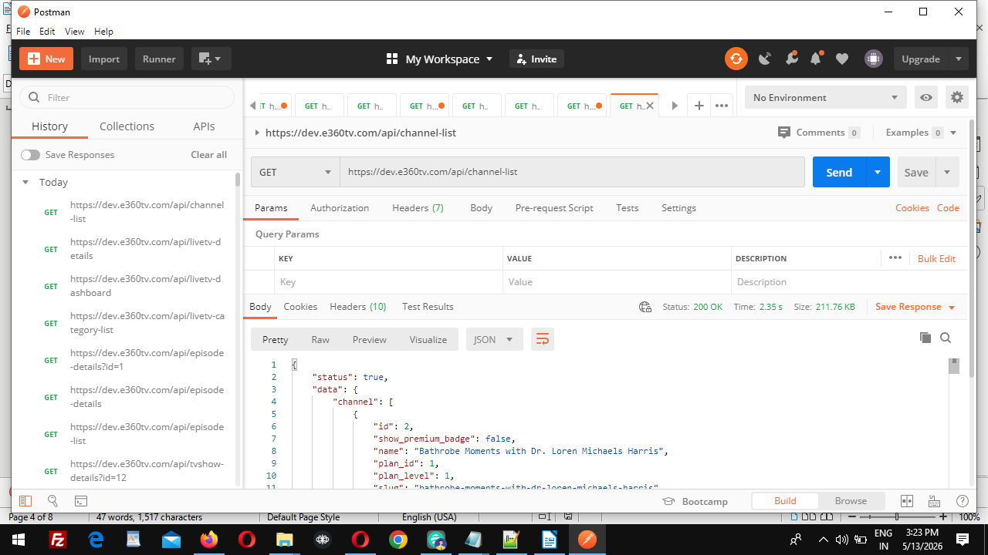
-----------------------------------------------------------------------------------

VIDEO RELATED API

video-list API
https://dev.e360tv.com/api/video-list
method get

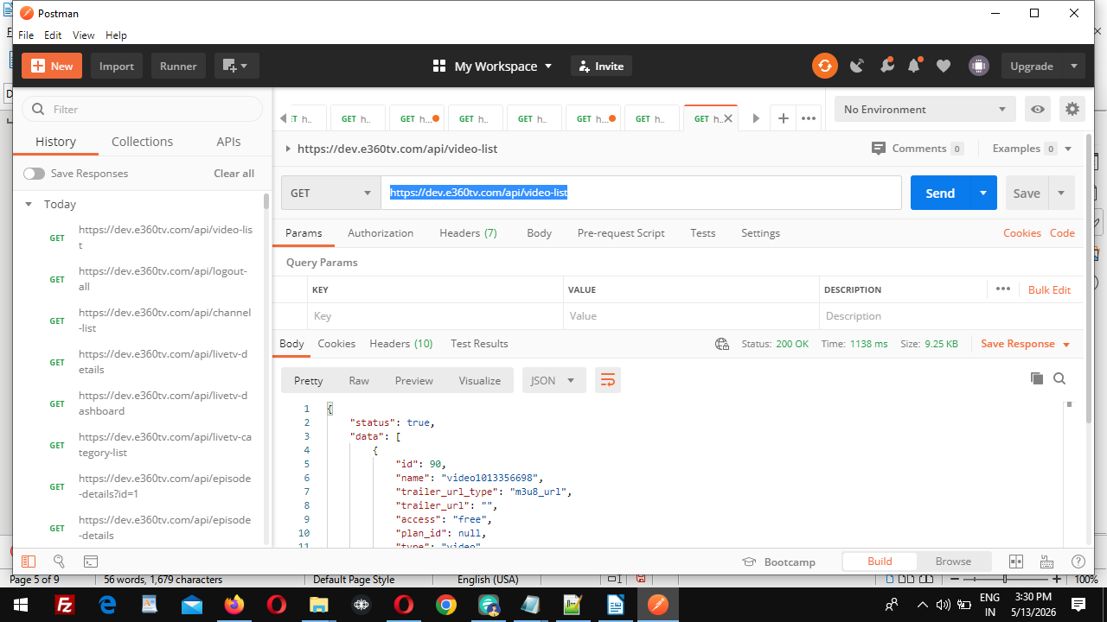
-------------------------------------------------------------------------

video-details API

https://dev.e360tv.com/api/video-details (not working)
---------------------------------------------------------------------------------

USER API

USER LOGIN

https://dev.e360tv.com/api/login
method post
email,password

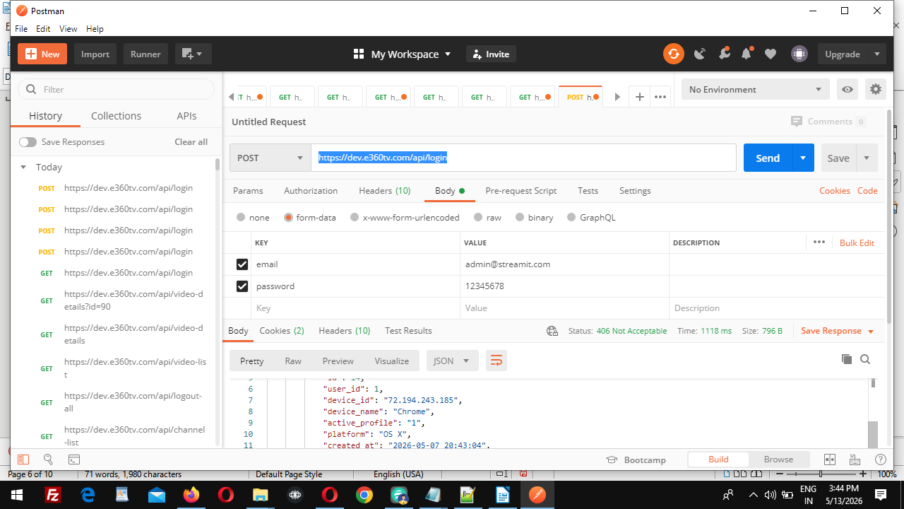

Register user api
https://dev.e360tv.com/api/register
method post
"first_name":"Ratnesh",
"last_name":"Kumar",
"email":"ratneshk500@gmail.com",
"password":"Ratnesh@1976",
"mobile":"783454646647"

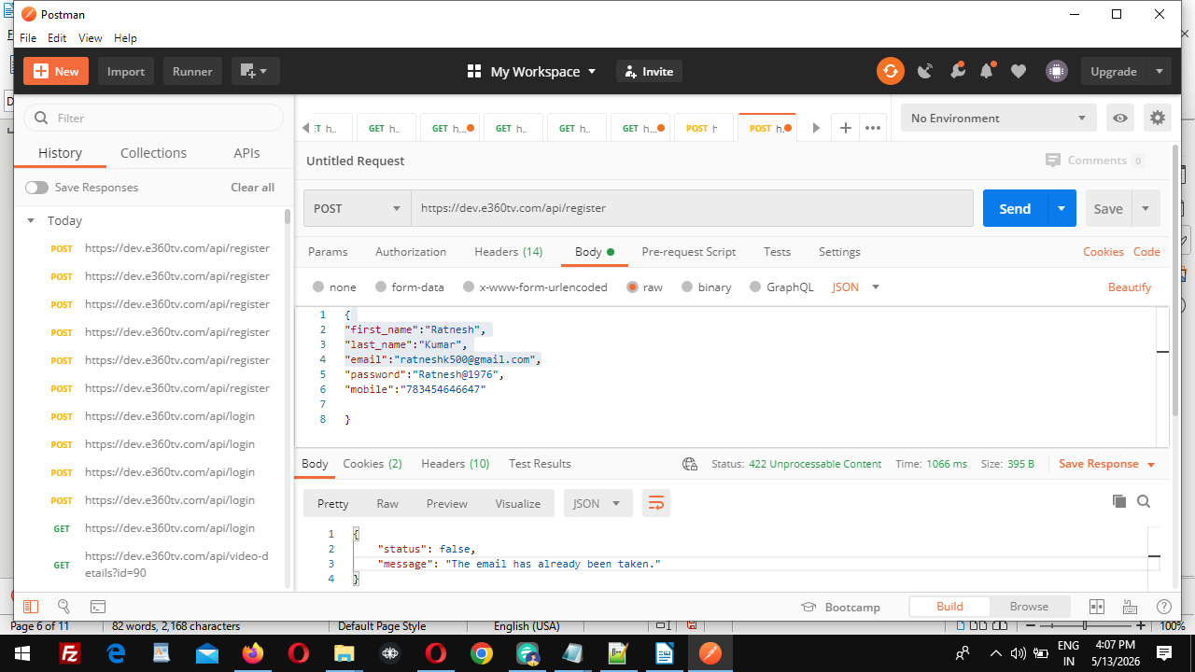
--------------------------------------------------------------------------------------------------------

tvshow-details details api
https://dev.e360tv.com/api/tvshow-details?tvshow_id=334
method get
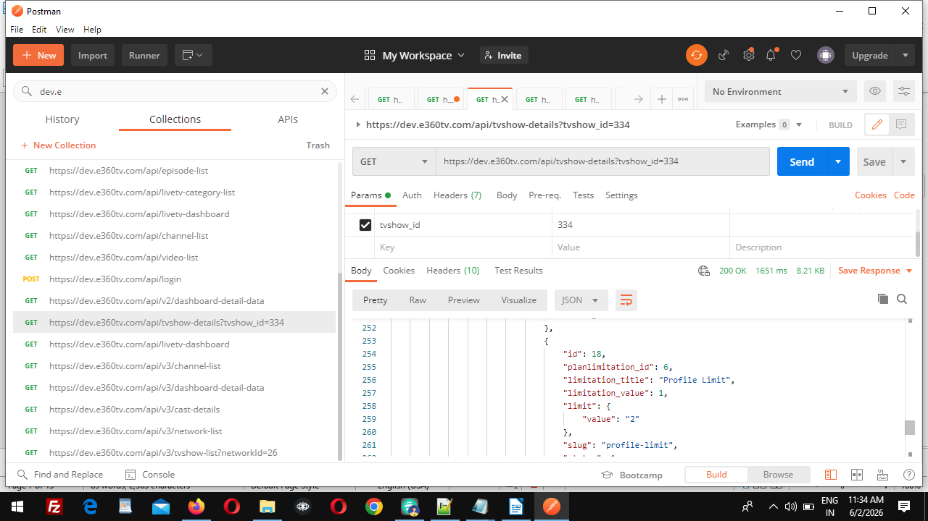

--------------------------------------------------------------------------------------

livetv details api
https://dev.e360tv.com/api/v3/livetv-details?channel_id=228

method get

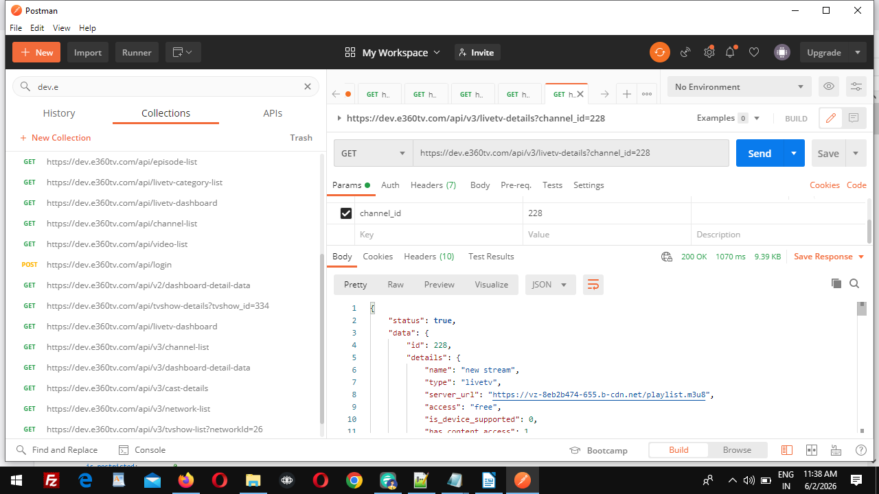
-------------------------------------------------

series network-list api
https://dev.e360tv.com/api/v3/network-list

method Get
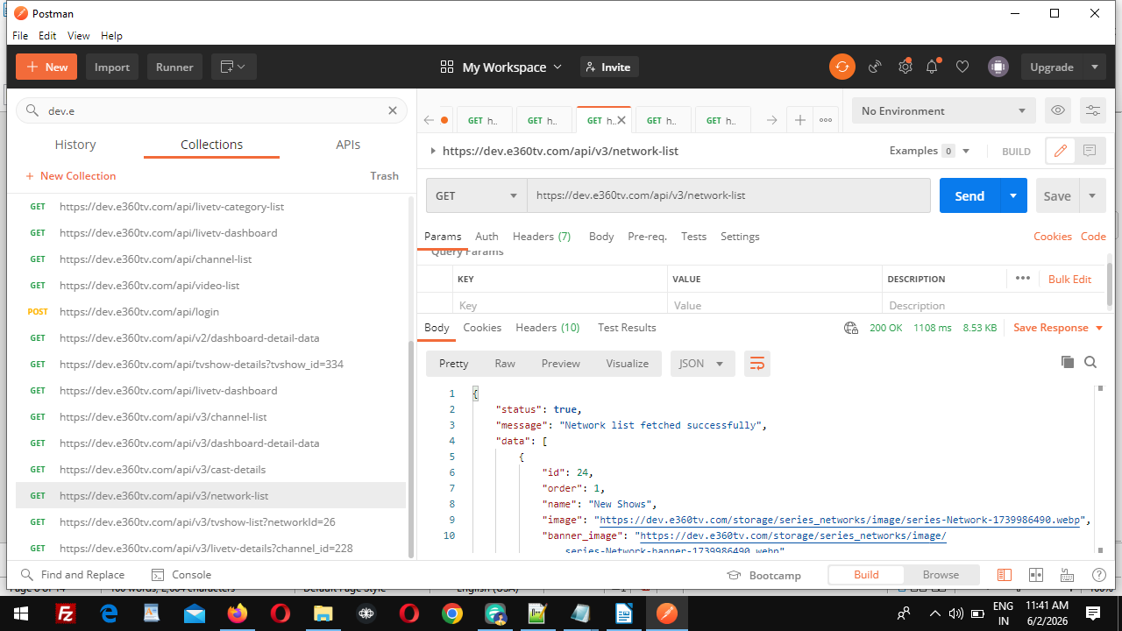
--------------------------------------------------------------
tvshow-list with network id api
https://dev.e360tv.com/api/v3/tvshow-list?networkId=26

Method Get

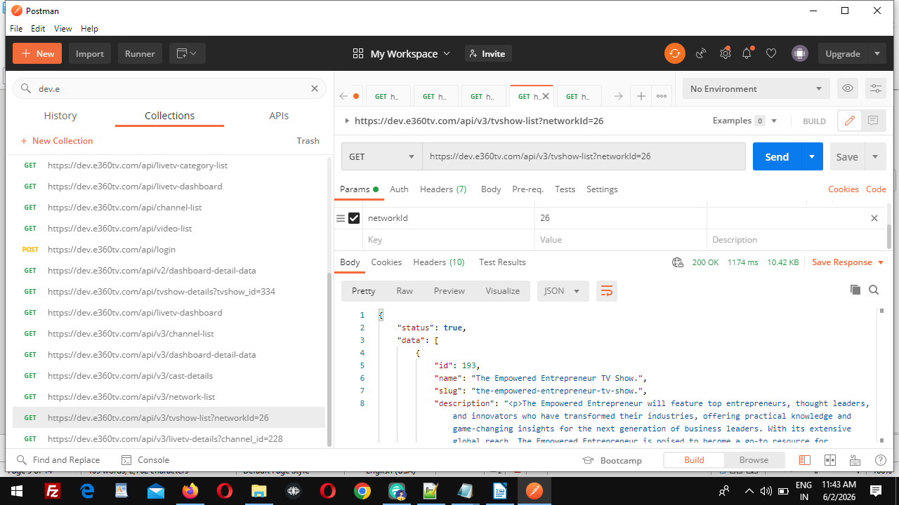
dashboard-detail-data API
https://dev.e360tv.com/api/v3/dashboard-detail-data
method get

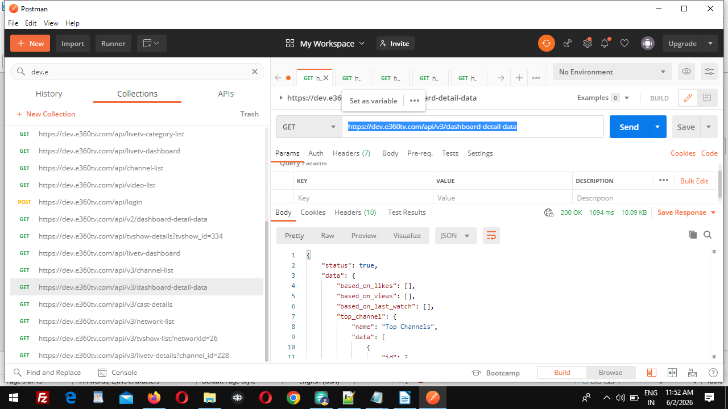

livetv-dashboard API
https://dev.e360tv.com/api/livetv-dashboard
method get

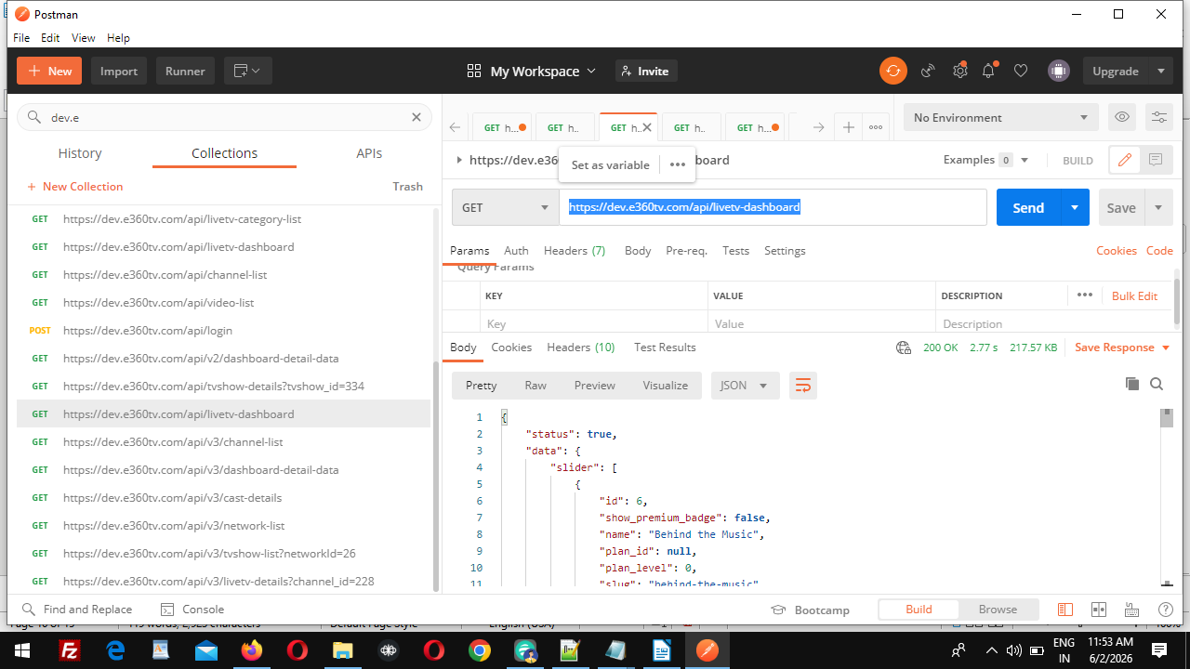
---------------------------------------------------------------------------
https://dev.e360tv.com/api/check-episode-purchase?episode_id=14328&user_id=15
check-episode-purchase api
method get
episode_id
user_id

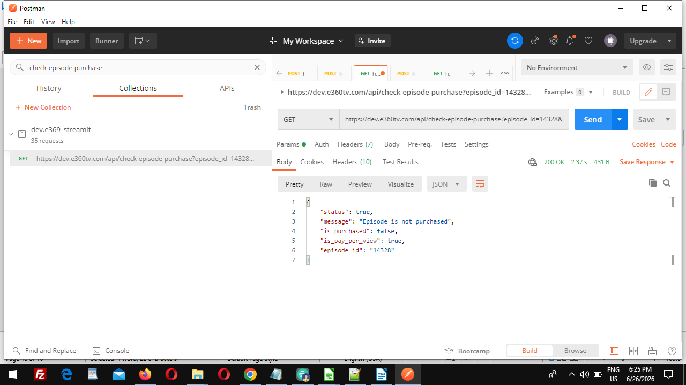

https://dev.e360tv.com/api/ppv/movies
ppv/movies api
method get

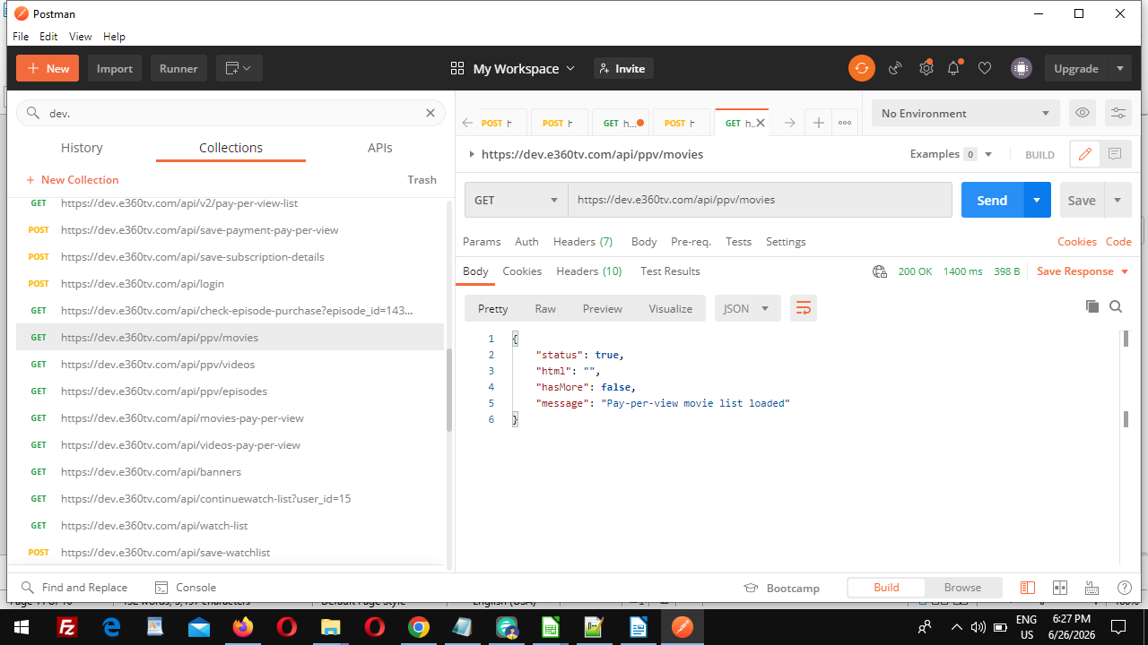
---------------------------------------------------
https://dev.e360tv.com/api/ppv/videos
ppv/videos api
method post

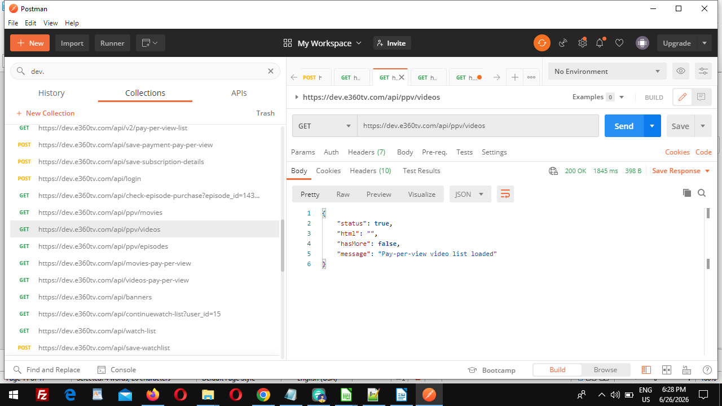

https://dev.e360tv.com/api/ppv/episodes
ppv/episodes api
method get

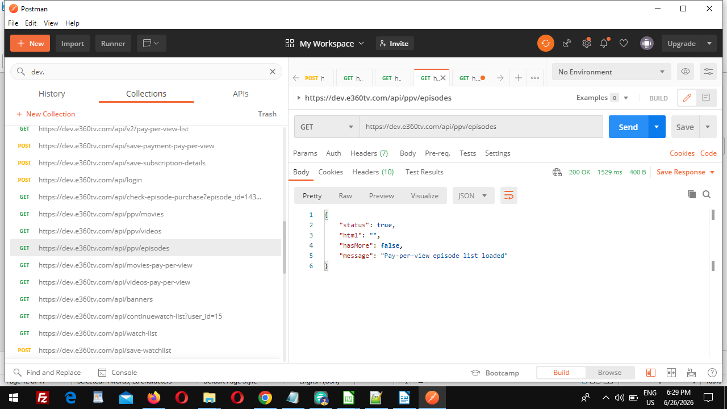
-------------------------------------------------------

https://dev.e360tv.com/api/movies-pay-per-view
movies-pay-per-view api
method get

-------------------------------------------------------------

https://dev.e360tv.com/api/tvshow-details?tvshow_id=335&user_id=15
tvshow-details api
method get
tvshow_id
user_id

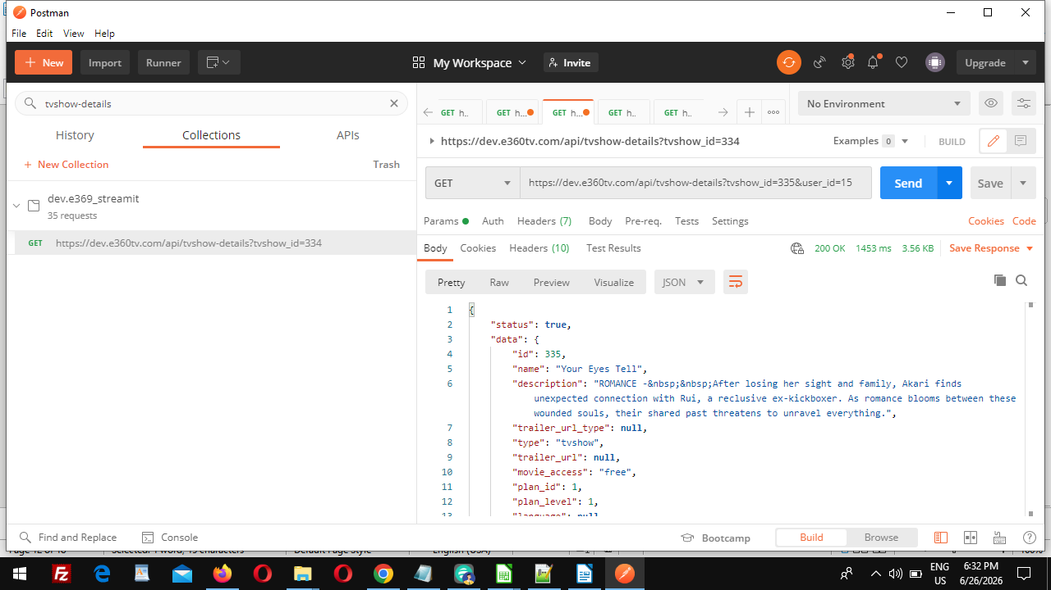
---------------------------------------------------------------------------
save watchlist api

https://dev.e360tv.com/api/save-watchlist
method post
entertainment_id
user_id
type
type =>(video,movie,tvshow)

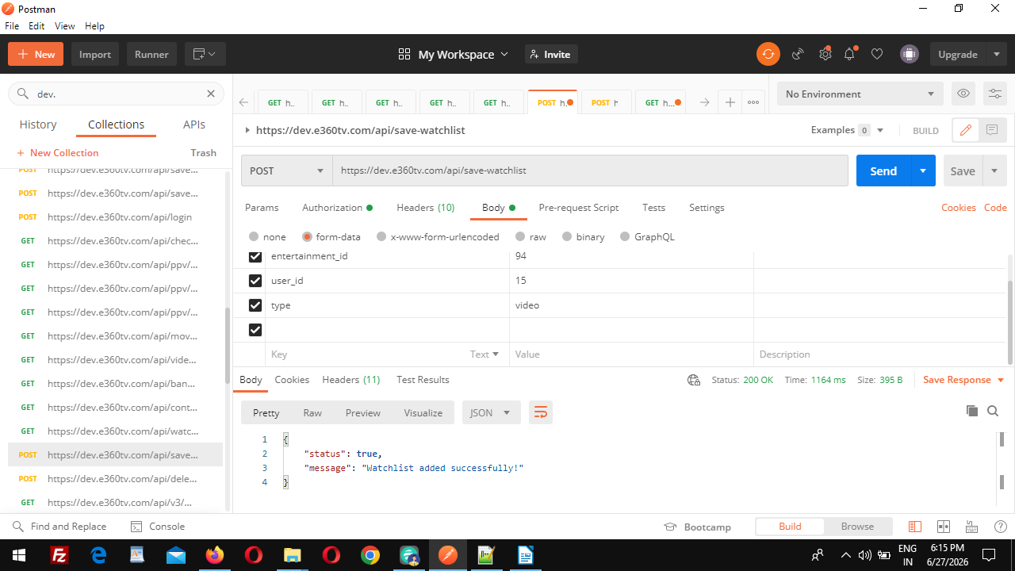

delete-watchlist api
https://dev.e360tv.com/api/delete-watchlist
method post
type
type =>(video,movie,tvshow)
user_id
id=>watch list id
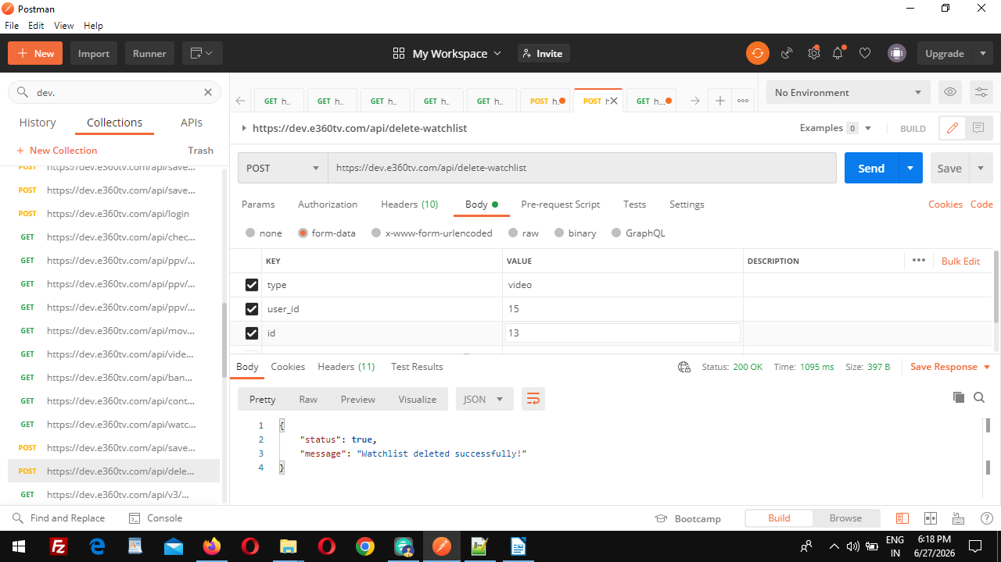
watch-list api
https://dev.e360tv.com/api/watch-list

